**New Era University**   
College of Computer Studies

Department of Computer Science

**In Partial Fulfillment of the Requirements in**

**CS321L Software Engineering Laboratory**

**DOCTAL: A web based Doctor’s Portal**

**Submitted by:**

Cania, Princess April S.

Comaling, JerickaAleli

Del Rosario, Merichelle L.

 Leones, Dainielle Andrea O.

Marticio, Maricar M.

**Class Schedule:**

Monday 10:00 AM – 1:00 PM

Professor Yumie M. Pasiol

**Instructor**

**INTRODUCTION**

In a world constantly growing and expanding, having a health care system to the field of computer is a good approach for hospitals. Technology is constantly improving so a paperless medical record system is more practical and sensible instead of rummaging through papers and losing them or misplacing those important documents. Computers provide an easier way to look up for a patient’s information if a doctor asks for it. Computers allow the patient to grasp a visual perspective of their health. Health care systems could create more advanced way of recording and understanding a patient’s situation. Without computers for the doctor and patient communication, all transactions and interaction must be done through telephone or by the office. Having the health care system will allow the doctor and the patient to stay in contact more often through communication on technology.

This study proposes on having an efficient doctor-patient portal, wherein patients can book a reservation or make an appointment through doctors online or with the presence of the internet which will both benefit the doctor and the patient.

**COMPANY PROFILE**

The group Undecided XXVII was formed for the course CS312L (Software Engineering Laboratory). The members consist of 5 girls who have accomplished different case studies during their previous years with other teams. The group can work as a team even though they have different skills, which is an advantage because they can help each other grow and be able to finish their task.

**Organizational Structure**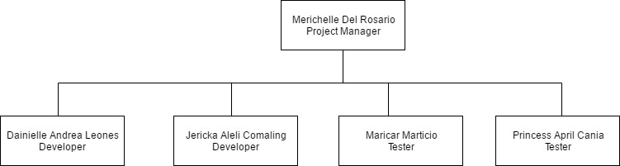

**BACKGROUND OF THE STUDY**

Making an appointment to a doctor, especially in a hospital where a lot of patients are in need of care seems to be hard. There are a lot of processes that is needed to be done before you can set an appointment to your doctor.

By proposing this doctor-patient handling managing system, the doctors will lessen their work and also the patients in booking doctor appointments.

**OBJECTIVES**

To develop a system that will help the user/patient to know easily who the doctor in-charge is and to know immediately the other information that the patient needs to know.

The following are the specific objectives that the researchers are aiming to do:

* To help the user/patient to easily find a doctor that suits to their condition/case.
* To lessen their time going to hospital to check if there is an available doctor to check on their condition.
* To easily check the background of the doctor and the achievements they have done.

**SCOPES AND LIMITATIONS**

The scope of our system is that it will be able to show the medical progress of a doctor, it will also allow to search for doctors depending on their specialization and location. The user can also set for an appointment with their chosen doctor and will receive a confirmation through e-mail.

The proposed study is limited to those who have internet connection. And only 5 specializations will be used as an example and 2 doctors per specialization.

**GANTT CHART**

**Table**

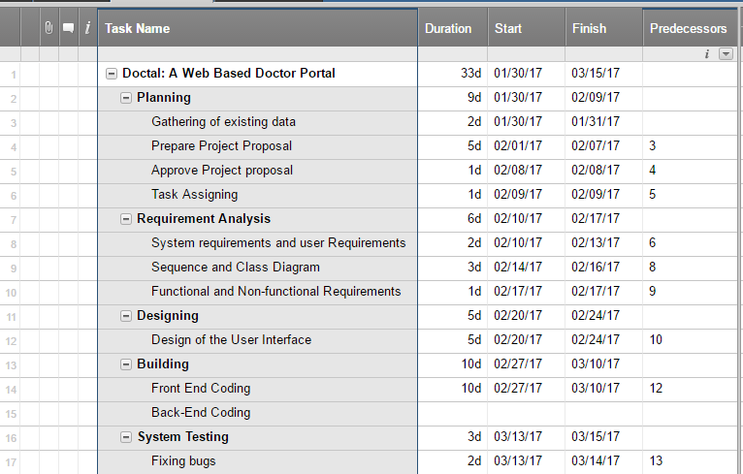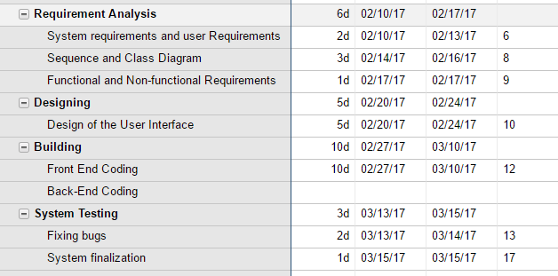

**Diagram**

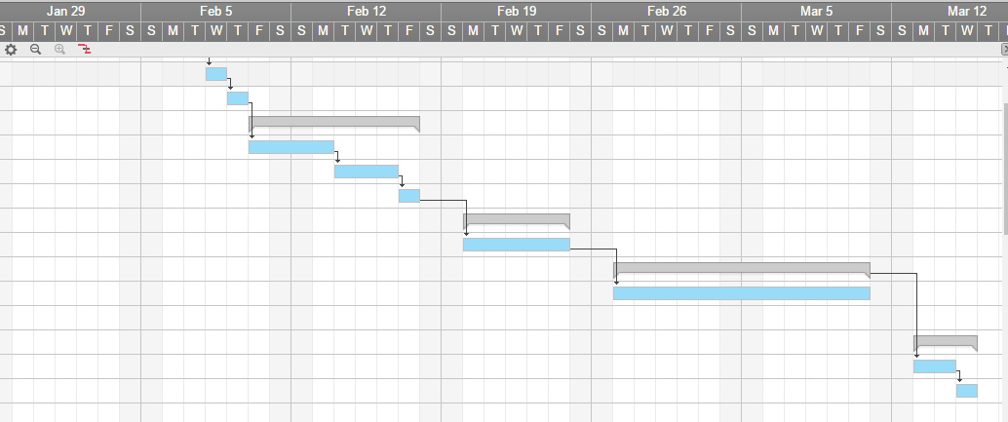

**SDLC**

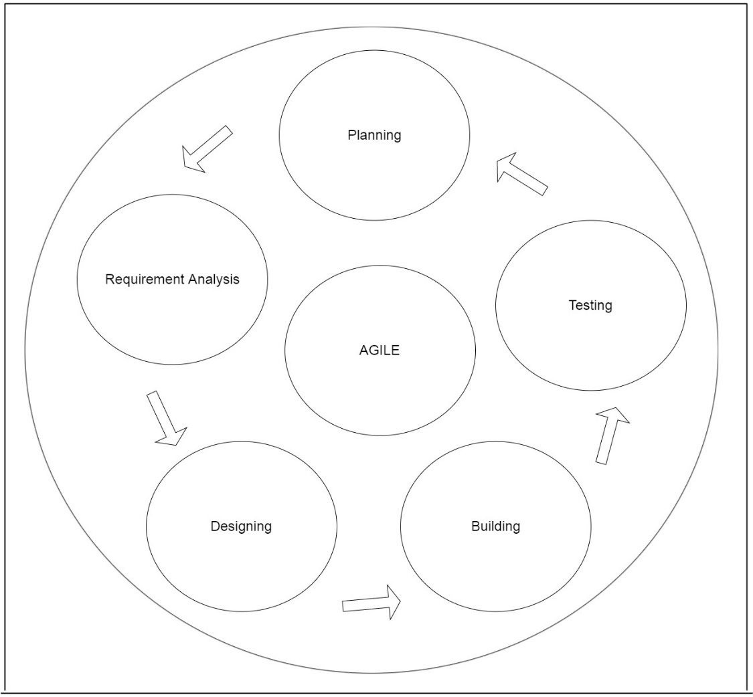

The first process is planning, inside this process are the preparing the project proposal, the approval of the proposal, the gathering of data and the task assigning. The second process is requirement analysis, in this process are the system and user requirement, sequence and class diagram and the function and non-functional requirements. The third process is designing, in this process the designing of the user interface happened. The fourth process is building, the coding stage of the project. And the last process is testing, researchers will test the system and also fix the bugs.

**USER REQUIREMENTS**

1. **Patient**

1.1 Doctal is a web based system that will allow the patient to find a doctor that will help them in their need.

* 1. The system will provide the user to locate the nearest doctor available in the city.
  2. The user can search a doctor by entering the needed specialist and its location or address, in order for the system to find the nearest doctor in the area.
  3. User can also reserve the doctor’s appointment only if the doctor is available on the said date.
  4. User can also give the doctor feedback and the doctor won’t know who send the feedback.

1. **Doctors**

2.1 Doctors will approve or not, the reservation of the patient.

2.2 Doctors will send the patients email of acceptation.

2.3 Doctors will receive feedback from the patient.

**3.0 Admin**

3.1 Admin is the only one who can handle the System Maintenance.

3.2 Admin can see the name of the feedback sender.

3.3 Admin can shut down the system.

3.4 The ability of the patient can be done by the admin as well.

**SYSTEM REQUIREMENTS**

* The user must have an internet connection to have an access to the system.

**UI DESIGN INTERACE**

UID 1.0 Sign-Up

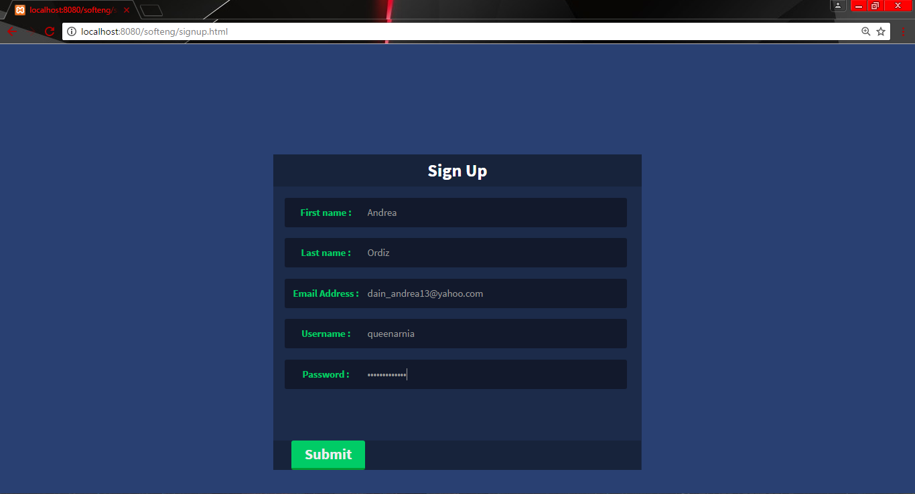

UID 2. 0 Login

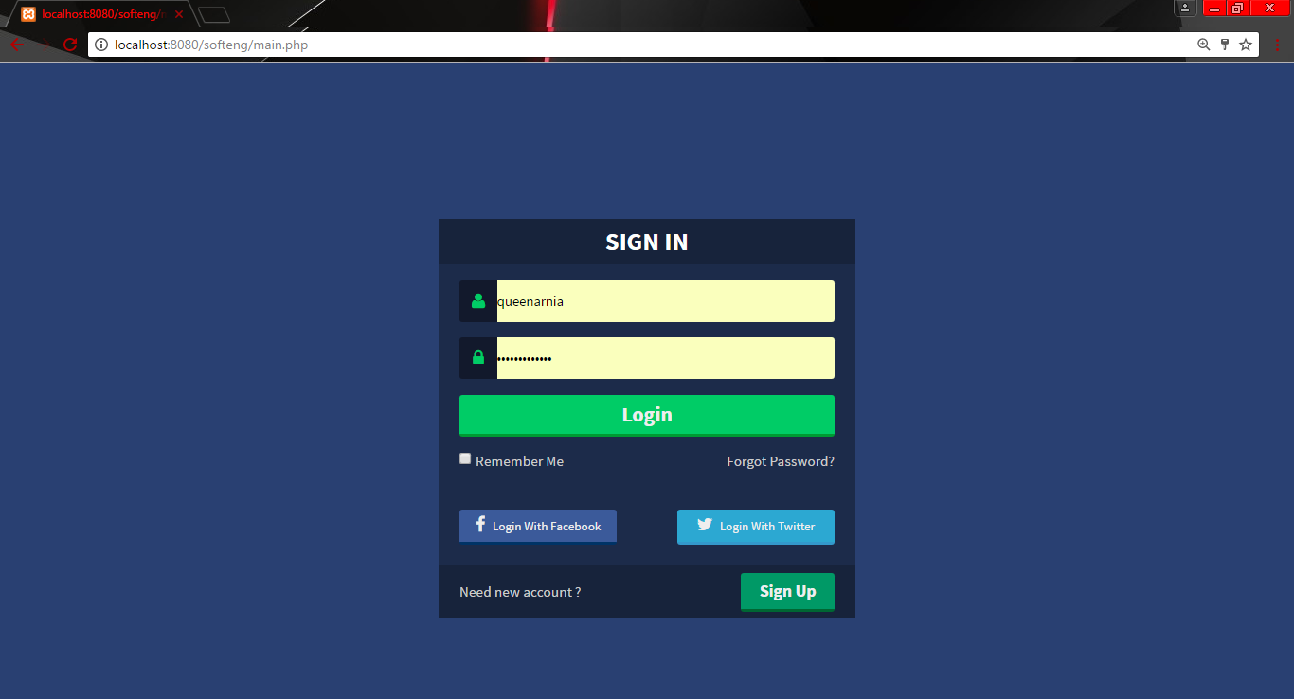

UID 3.0 Home

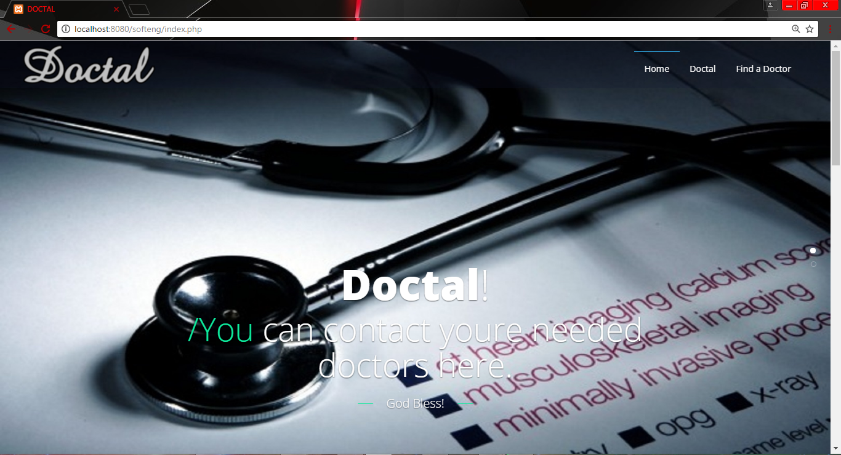

UID 4.0 Doctal

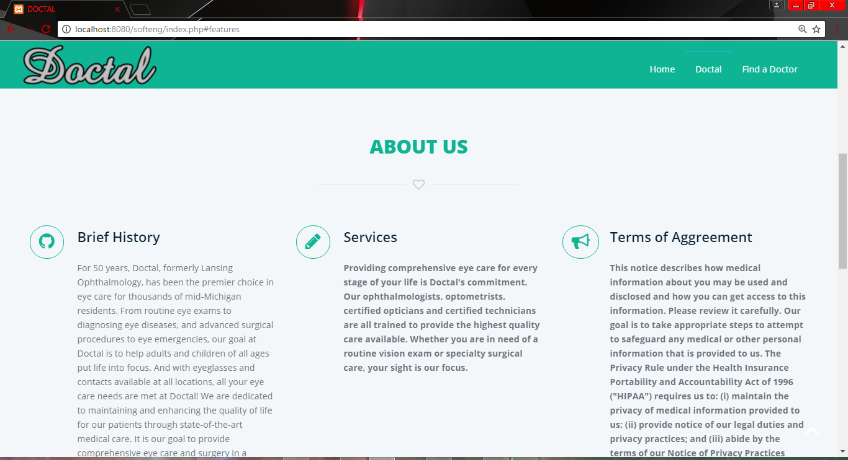

UID 5.0 Find A Doctor

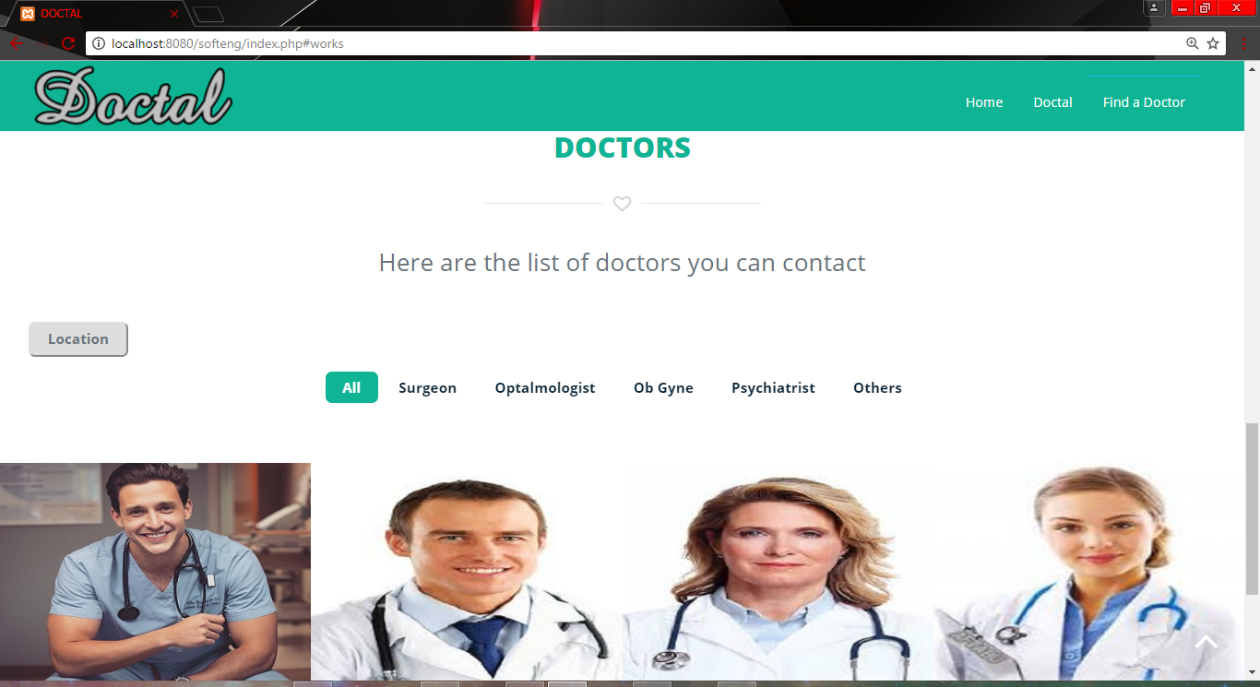

UID 6.0 Doctor’s Profile

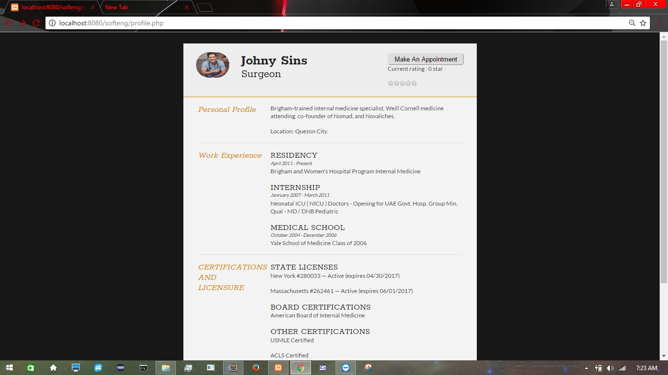

UID 7.0 Make an Appointment

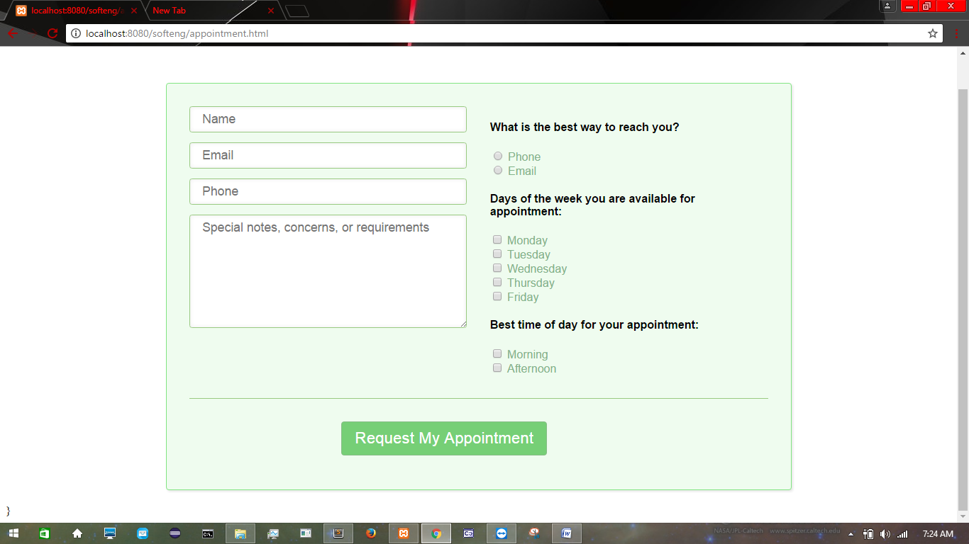

**ACTIVITY DIAGRAM**

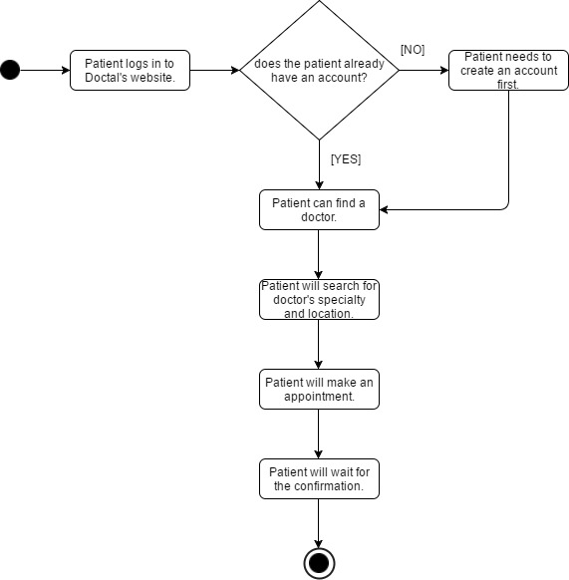

**USE CASE DIAGRAM**

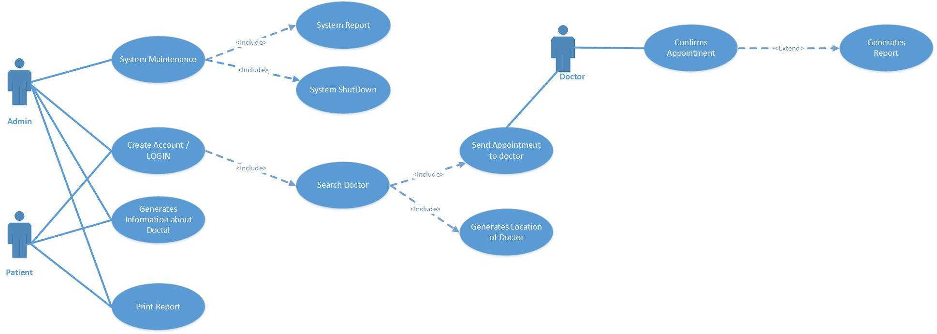

**SEQUENCE DIAGRAM**

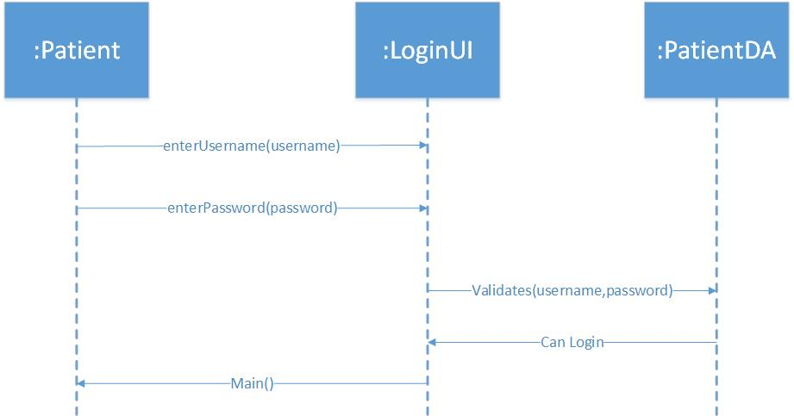**User Login**

**Search Doctor**

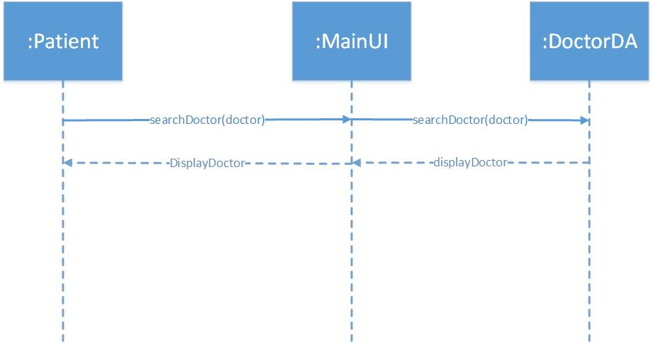

**Send appointment to doctor**

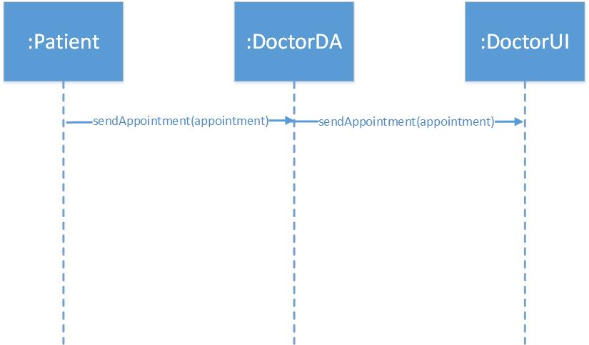

**Generates Doctor Location**

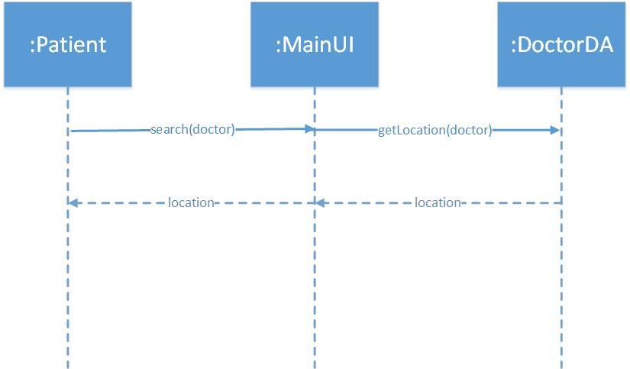

**Confirms Appointment**

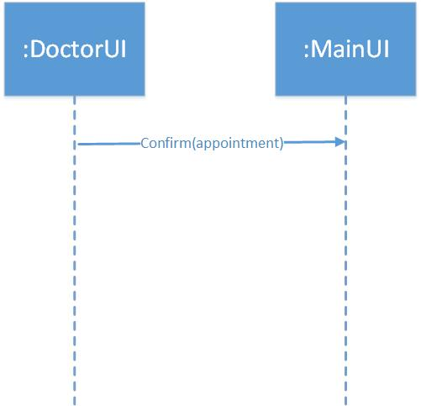

**Generates Report**

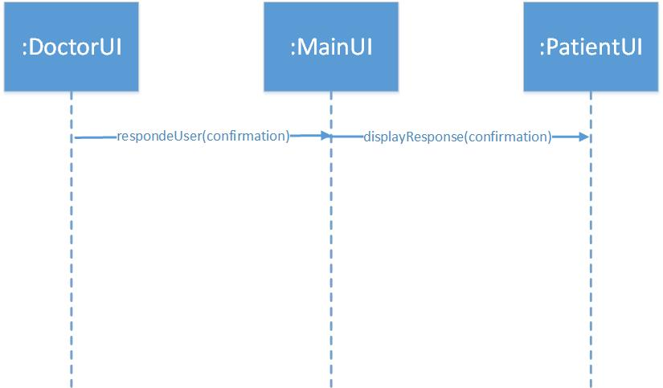

**Generates Information about DOCTAL**

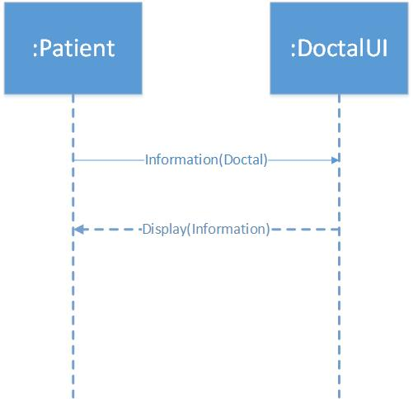

**System Maintenance**

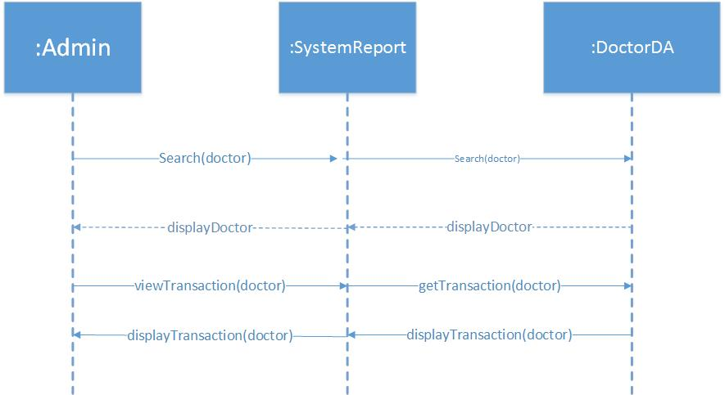

**System Report**

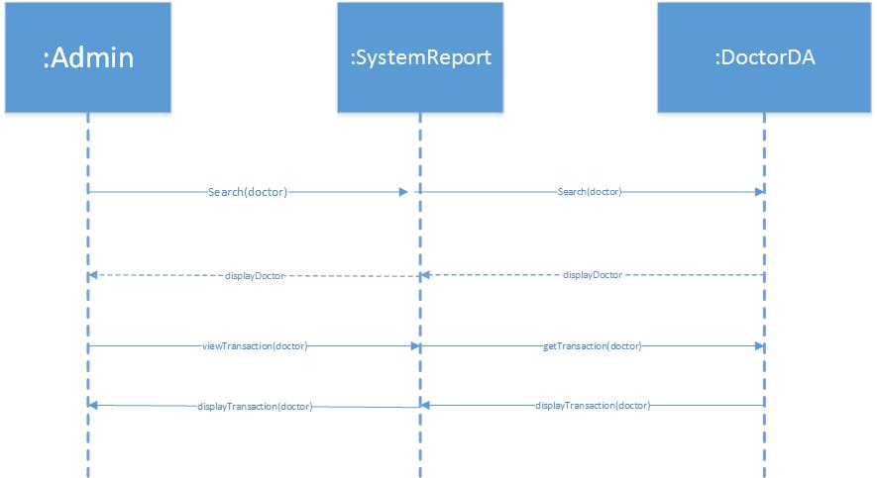

**System Shutdown**

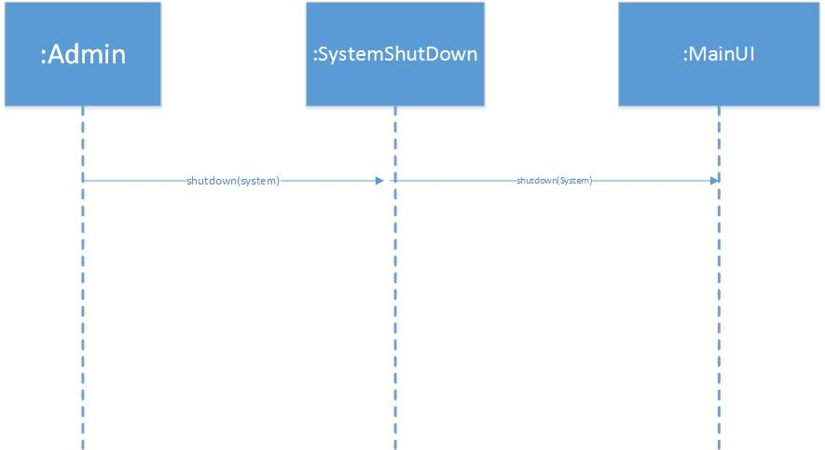

**Print Report**

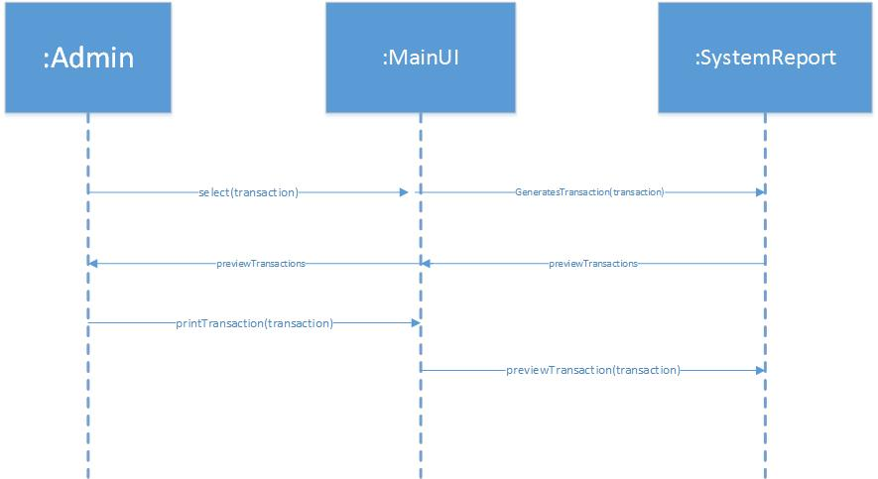

**CLASS DIAGRAM**

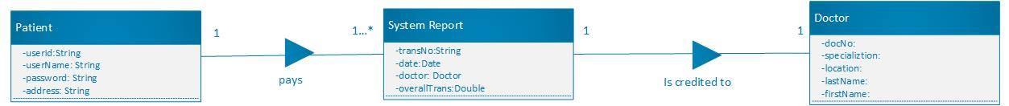

**USER MANUAL**



1



2

3



4





5



6



7

1. **Sign Up** - User will fill up the form that will be submitted.

2. **Login** - User will use the username and password created to access the webpage.

3. **Home** - Views the home page.

4. **Doctal** - Information about the webpage.

5. **Find a doctor** - Display the information about the doctors (Specialization, Location, certifications)

6. **Make an appointment** -Display the form to be filled up.

7**. Request my Appointment** - Sends the information of the user.

**TEST SCRIPT**

|  |  |  |  |  |  |
| --- | --- | --- | --- | --- | --- |
| **Scenarios** | **Sub Levels** | **Complexity** | **Date of Execution** | **Status** | **Defect Description** |
| Log In Page | Log In | Medium | 03/04/2017 | Passed |  |
| Main Menu | Search for a Doctor | Medium | 03/28/2017 | Passed |  |
| Sub Menu | Choose a Doctor | Complex | 04/01/2017 | Not yet executed |  |
|  | Make an appointment | Complex | 04/01/2017 | Not yet executed |  |

**CODE LISTING**

**Sign-up HTML**

<!DOCTYPE html>

<html lang="en-us">

<meta charset="utf-8" />

<head>

<meta name="viewport" content="width=device-width, initial-scale=1.0">

<!-- <link rel="stylesheet" href="css/styles.css"> -->

<script type="text/javascript" src="jquery-3.2.0.min.js"></script>

<script type="text/javascript" src="script.js"></script>

<style>

@import url("http://maxcdn.bootstrapcdn.com/font-awesome/4.3.0/css/font-awesome.min.css");

@import url("http://fonts.googleapis.com/css?family=Source+Sans+Pro:400,700");

*{margin:0; padding:0}

body{background:#294072; font-family: 'Source Sans Pro', sans-serif}

.form{width:500px; margin:0 auto; background:#1C2B4A; margin-top:150px}

.header{height:44px; background:#17233B}

.header h2{height:44px; line-height:44px; color:#fff; text-align:center}

.login{padding:0 15px}

.login span.un{width:24%; text-align:center; color:#0C6; border-radius:3px 0 0 3px}

.text{background:#12192C; width:75%; border-radius:0 3px 3px 0; border:none; outline:none; color:#999; font-family: 'Source Sans Pro', sans-serif}

.text,.login span.un{display:inline-block; vertical-align:top; height:40px; line-height:40px; background:#12192C;}

ul li{height:40px; margin:15px 0; list-style:none}

.ch{display:inline-block; width:50%; color:#CCC}

.ch a{color:#CCC; text-decoration:none}

.ch:nth-child(2){text-align:right}

.sign{width:90%; padding:0 5%; height:40px; display:table; background:#17233B}

.sign div{display:inline-block; width:10%; line-height:15px; color:#ccc; font-size:14px}

.up{text-align:right}

.btn{height:40px;border:none; width: 100px; background:#0C6; outline:none; font-family: 'Source Sans Pro', sans-serif; font-size:20px; font-weight:bold; color:#eee; border-bottom:solid 3px #093; text-align:center; border-radius:3px; cursor:pointer}

@media(max-width:480px){ .form{width:100%}}

</style>

</head>

<body>

<div class="form">

<div class="header"><h2>Sign Up</h2></div>

<div class="login">

<form method = 'post'>

<ul>

<li>

<span class="un"><H5>First name : </H5></span><input type="text" id="fn" name = 'firstname' required class="text" placeholder="DSDSD"/></li>

<li>

<span class="un"><H5>Last name : </H5></span><input type="text" id="ln" name = 'lastname' required class="text" placeholder=""/></li>

<li>

<span class="un"><H5>Email Address : </H5></span><input type="text" id="email" name = 'email' required class="text" placeholder=""/></li>

<li>

<span class="un"><H5>Username : </H5></span><input type="text" id="un" name = 'username' required class="text" placeholder=""/></li>

<li>

<span class="un"><H5>Password : </H5></span><input type="password" id="ps" name = 'dsdssd' required class="text" placeholder=""/></li>

<li>

</li>

</ul>

</div>

<div class="sign">

<input id="add" type="button" class="btn btn-primary" value="Submit">

</form>

</div>

</div>

</body>

</html>

**Appointment HTML**

<html>

<head>

<title></title>

<link rel="stylesheet" href="css/appointment.css">

</head>

<body>

<div class="landing-page"><div class="form-appointment"><div class="wpcf7" id="wpcf7-f560-p590-o1"><form action="http://localhost:8080/softeng/index.php" method="post" class="wpcf7-form" novalidate="novalidate" _lpchecked="1">

<div style="display: none;">

<input type="hidden" name="_wpcf7" value="560">

<input type="hidden" name="_wpcf7_version" value="3.5">

<input type="hidden" name="_wpcf7_locale" value="">

<input type="hidden" name="_wpcf7_unit_tag" value="wpcf7-f560-p590-o1">

<input type="hidden" name="_wpnonce" value="dbb28877d5">

</div>

<div class="group">

<div style="width: 48%; float: left;">

<span class="wpcf7-form-control-wrap text-680"><input type="text" name="text-680" value="" size="45" class="wpcf7-form-control wpcf7-text wpcf7-validates-as-required" aria-required="true" placeholder="Name"></span><br>

<span class="wpcf7-form-control-wrap email-680"><input type="email" name="email-680" value="" size="45" class="wpcf7-form-control wpcf7-text wpcf7-email wpcf7-validates-as-required wpcf7-validates-as-email" aria-required="true" placeholder="Email"></span><br>

<span class="wpcf7-form-control-wrap tel-630"><input type="tel" name="tel-630" value="" size="45" class="wpcf7-form-control wpcf7-text wpcf7-tel wpcf7-validates-as-required wpcf7-validates-as-tel" aria-required="true" placeholder="Phone"></span><br>

<span class="wpcf7-form-control-wrap textarea-398"><textarea name="textarea-398" cols="40" rows="10" class="wpcf7-form-control wpcf7-textarea" placeholder="Special notes, concerns, or requirements"></textarea></span></div>

<div style="width: 48%; float: right;">

<h4>What is the best way to reach you?</h4>

<p><span class="wpcf7-form-control-wrap radio-98"><span class="wpcf7-form-control wpcf7-radio"><span class="wpcf7-list-item"><label><input type="radio" name="radio-98" value="Phone">&nbsp;<span class="wpcf7-list-item-label">Phone</span></label></span><span class="wpcf7-list-item"><label><input type="radio" name="radio-98" value="Email">&nbsp;<span class="wpcf7-list-item-label">Email</span></label></span></span></span></p>

<h4>Days of the week you are available for appointment:</h4>

<p><span class="wpcf7-form-control-wrap checkbox-465"><span class="wpcf7-form-control wpcf7-checkbox"><span class="wpcf7-list-item"><label><input type="checkbox" name="checkbox-465[]" value="Monday">&nbsp;<span class="wpcf7-list-item-label">Monday</span></label></span><span class="wpcf7-list-item"><label><input type="checkbox" name="checkbox-465[]" value="Tuesday">&nbsp;<span class="wpcf7-list-item-label">Tuesday</span></label></span><span class="wpcf7-list-item"><label><input type="checkbox" name="checkbox-465[]" value="Wednesday">&nbsp;<span class="wpcf7-list-item-label">Wednesday</span></label></span><span class="wpcf7-list-item"><label><input type="checkbox" name="checkbox-465[]" value="Thursday">&nbsp;<span class="wpcf7-list-item-label">Thursday</span></label></span><span class="wpcf7-list-item"><label><input type="checkbox" name="checkbox-465[]" value="Friday">&nbsp;<span class="wpcf7-list-item-label">Friday</span></label></span></span></span></p>

<h4>Best time of day for your appointment:</h4>

<p><span class="wpcf7-form-control-wrap checkbox-246"><span class="wpcf7-form-control wpcf7-checkbox"><span class="wpcf7-list-item"><label><input type="checkbox" name="checkbox-246[]" value="Morning">&nbsp;<span class="wpcf7-list-item-label">Morning</span></label></span><span class="wpcf7-list-item"><label><input type="checkbox" name="checkbox-246[]" value="Afternoon">&nbsp;<span class="wpcf7-list-item-label">Afternoon</span></label></span></span></span></p></div>

</div>

<div style="text-align: center; padding-top: 2em; border-top: 1px solid rgb(153, 202, 129); margin-top: 1em;"><input type="submit" value="Request My Appointment" class="wpcf7-form-control wpcf7-submit" onclick = "myFunction()"><img class="ajax-loader" src="#" alt="Sending ..." style="visibility: hidden;"></div>

<div class="wpcf7-response-output wpcf7-display-none"></div></form></div></div></div>

</body>

<script type="text/javascript">

function myFunction()

{

alert("Your request has been process!");

}

</script>

}

</html>

**Appointment CSS**

.group:after {

content: "";

display: block;

clear: both;

}

.landing-page {

width: 882px;

margin: 100px auto 0;

}

.landing-page *,

.landing-page *:before,

.landing-page *:after {

-webkit-box-sizing: border-box;

-moz-box-sizing: border-box;

box-sizing: border-box;

}

.landing-page .module {

border: 1px solid rgb(219, 219, 219);

border-radius: 4px;

float: left;

padding: 2em;

width: 48%;

}

.landing-page .module > *:last-child,

.landing-page .module > *:last-child > *:last-child,

.landing-page .module > *:last-child > *:last-child > *:last-child {

margin: 0;

padding: 0;

}

.landing-page .note {

background-color: rgb(236, 248, 236);

border: 1px dashed;

border-radius: 4px;

color: rgb(115, 136, 96);

font-family: georgia;

font-size: .9em;

font-style: italic;

margin: 20px auto;

padding: 2em;

}

.form-appointment {

padding: 2em;

background-color: rgb(239, 252, 239);

border-radius: 4px;

border: 1px solid rgb(130, 228, 130);

box-shadow: 2px 2px 4px 0px rgba(0, 0, 0, 0.1);

font-family: 'PT Sans', Arial, sans-serif;

margin: 20px auto;

}

.form-appointment input[type=text],

.form-appointment input[type=email],

.form-appointment input[type=tel],

.form-appointment textarea {

border: 1px solid rgb(153, 202, 129);

border-radius: .2em;

font-family: 'PT Sans', Arial, sans-serif;

font-size: 1.1em;

padding: .4em 1em;

margin: 0 0 .8em;

width: 100%;

box-shadow: 0 0 8px rgba(0,0,0,.08) inset;

}

.form-appointment input[type=text],

.form-appointment input[type=email],

.form-appointment input[type=tel],

.form-appointment input[type=submit],

.form-appointment textarea {

-webkit-transition: all .2s ease-in-out;

-moz-transition: all .2s ease-in-out;

transition: all .2s ease-in-out;

}

.form-appointment input[type=text]:active,

.form-appointment input[type=text]:focus,

.form-appointment input[type=email]:active,

.form-appointment input[type=email]:focus,

.form-appointment input[type=tel]:active,

.form-appointment input[type=tel]:focus,

.form-appointment textarea:active,

.form-appointment textarea:focus {

outline: 0;

box-shadow: 0 0 6px rgb(176, 226, 188);

}

.form-appointment textarea {

height: 160px;

}

.form-appointment input[type=submit] {

background-color: rgb(118, 207, 118);

border: 1px solid rgb(134, 189, 134);

border-radius: 4px;

color: rgb(255, 255, 255);

cursor: pointer;

font-family: inherit;

font-size: 1.4em;

padding: 10px 18px;

}

.form-appointment input[type=submit]:hover {

background-color: white;

color: rgb(118, 207, 118);

}

.form-appointment .wpcf7-list-item-label {

color: rgb(130, 178, 136);

}

span.wpcf7-list-item {

display: block;

margin-left: -.02em;

}